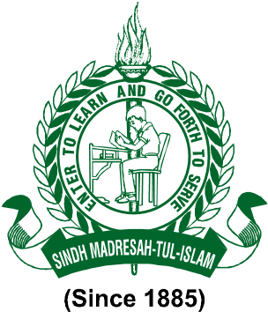

SINDH MADRESSAH TUL ISLAM BOARD

CONTINUOUS PROFESSIONAL DEVELOPMENT PLAN

Training Area | Topic | Trainers | Trainees | Responsibility
SMB Orientation | School as a learning community (as per TNA Basis | Education Expert, HM, DO and Coordinator | Management Staff | SMB
Health & Hygiene | School cleanliness | HMs | Supporting staff | HM and EMO coordinator

To educate parents and kids about the school's policies, the Sindh Madressah Board held an orientation session. The improvement of the school system was greatly aided by this orientation session. It will assist us in raising the school's attendance and dropout rates. SMC was invited to this session as well.
The school invited the Dettol team to provide a health and hygiene program. In the 8L school and Frontier colony, the Dettol crew completed this task, while LHV assisted the ECE and primary teachers in Sindhi Jamat and Waryo Gabol schools.
The EMIS system was covered in the training for the IT operators. Ms. Huma Jabeen, the Compliance Manager, arranged this training to help the Governemnt and Management of SMB to monitor the system online and ensure that the data are saved on time. All of the IT operators of newly built and consolidated schools received this instruction.
Teachers received a refresher session on lesson planning and daily diaries. Teachers were also instructed on the curriculum since they were so distracted that pupils' grades were below grade level and it would be hard for us to cover the material in accordance with the Sindh Madressah Board's syllabus coverage.
PICTURES

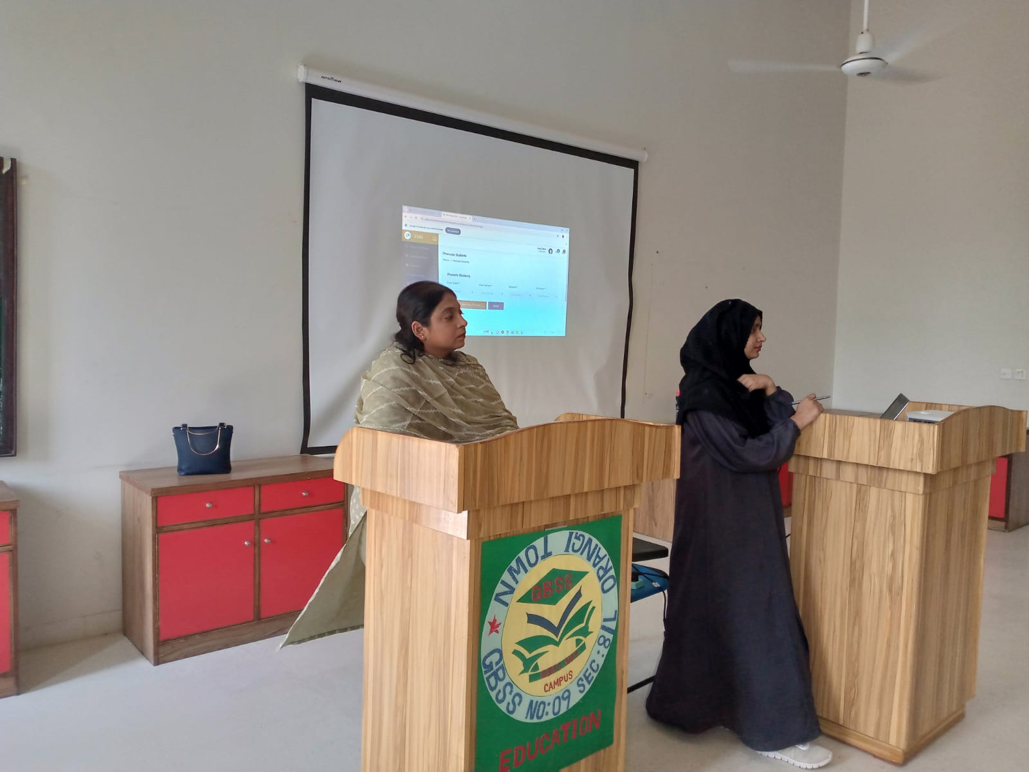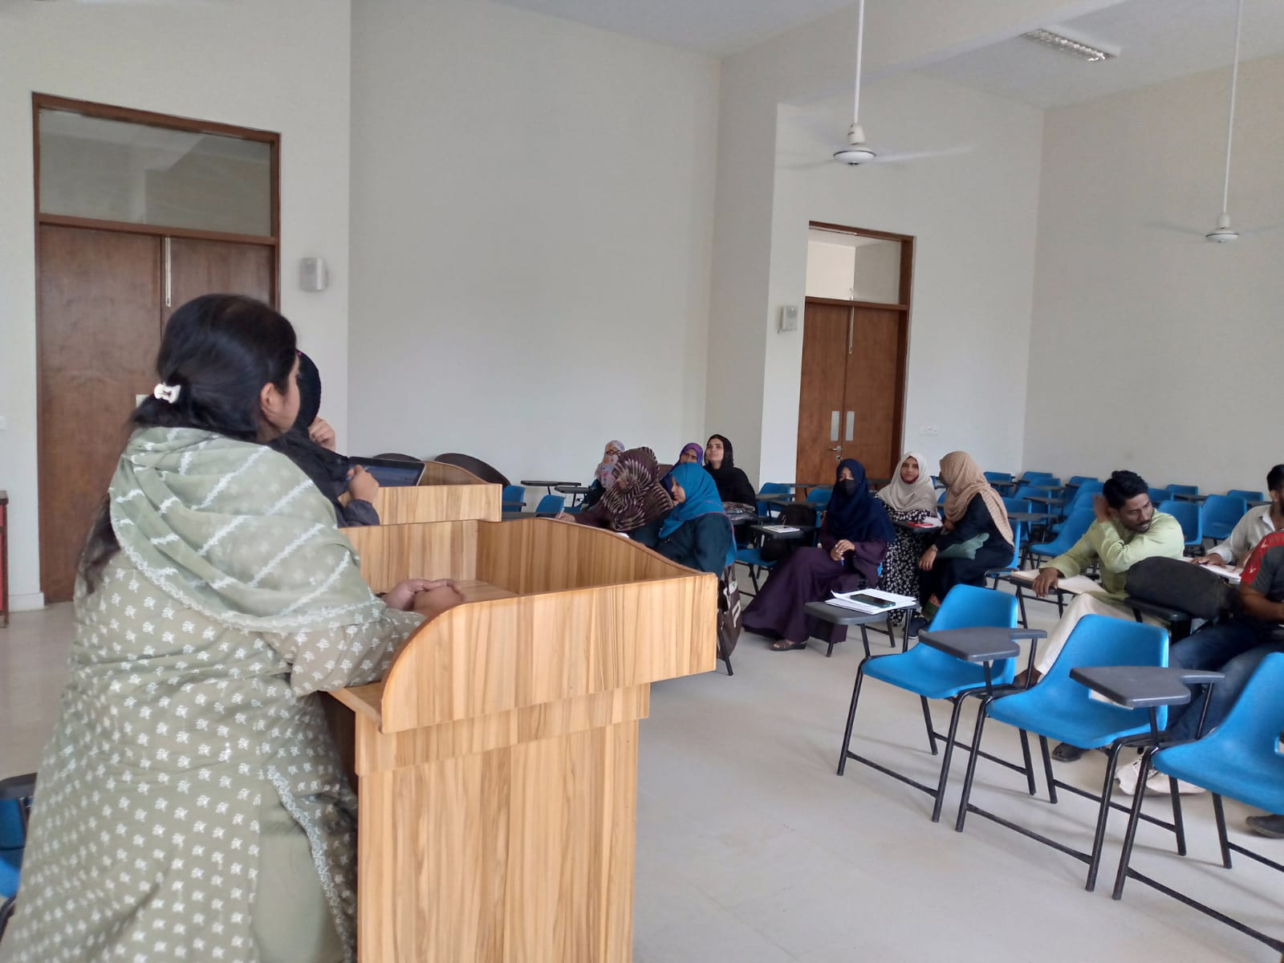
WORKSHOP REGARDING EMIS
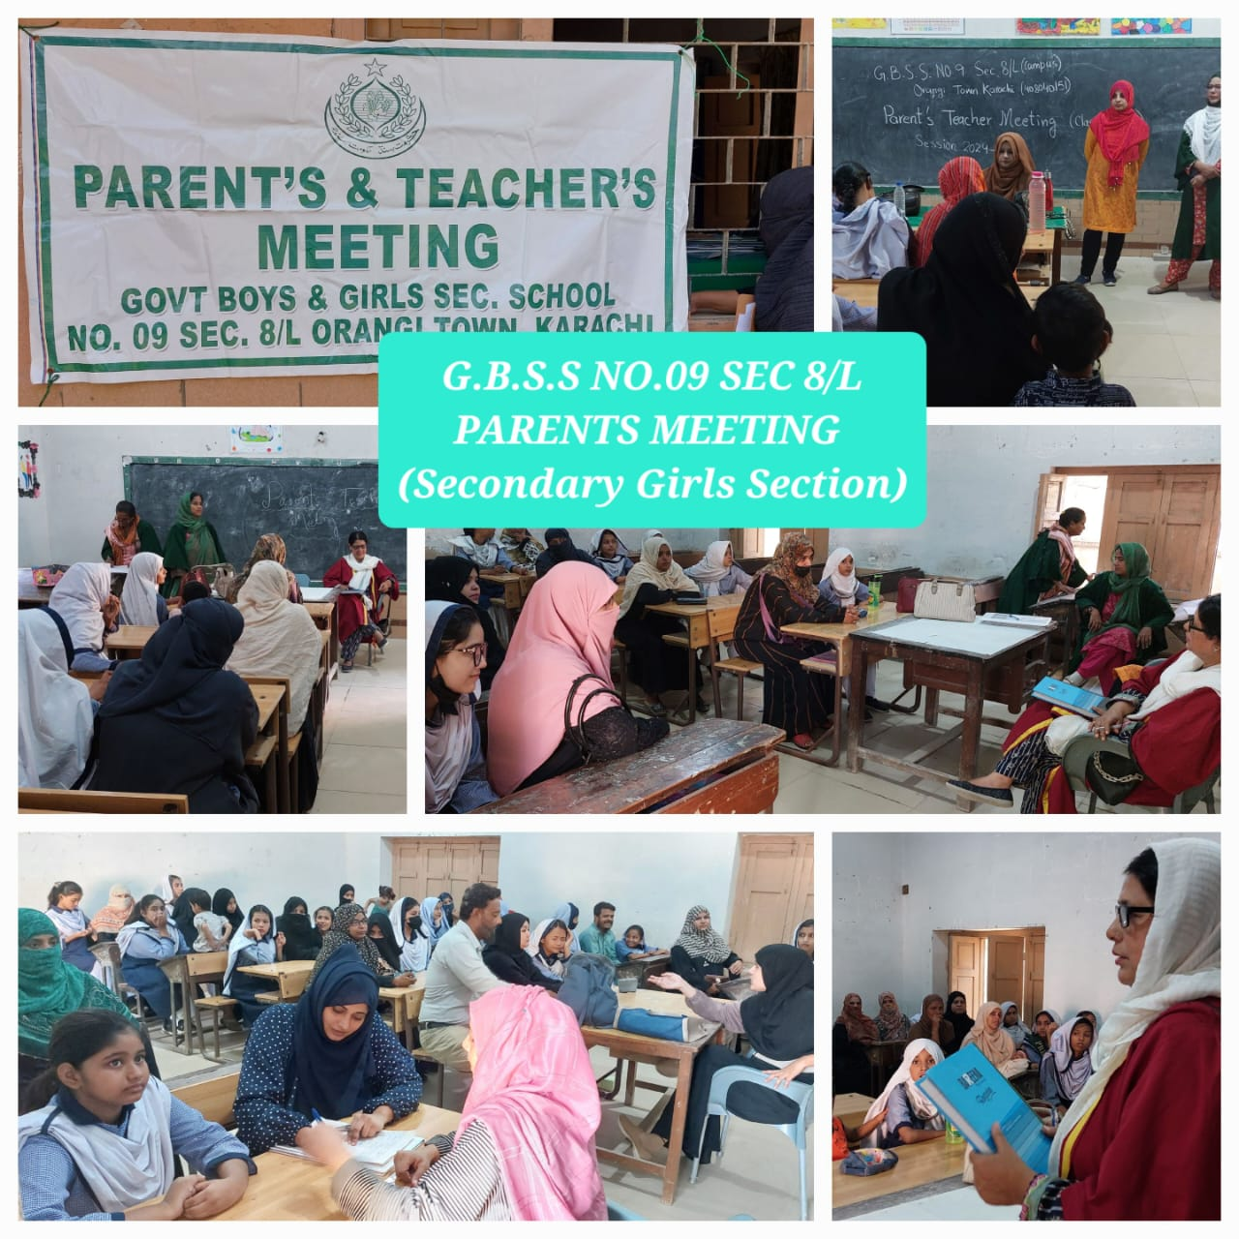
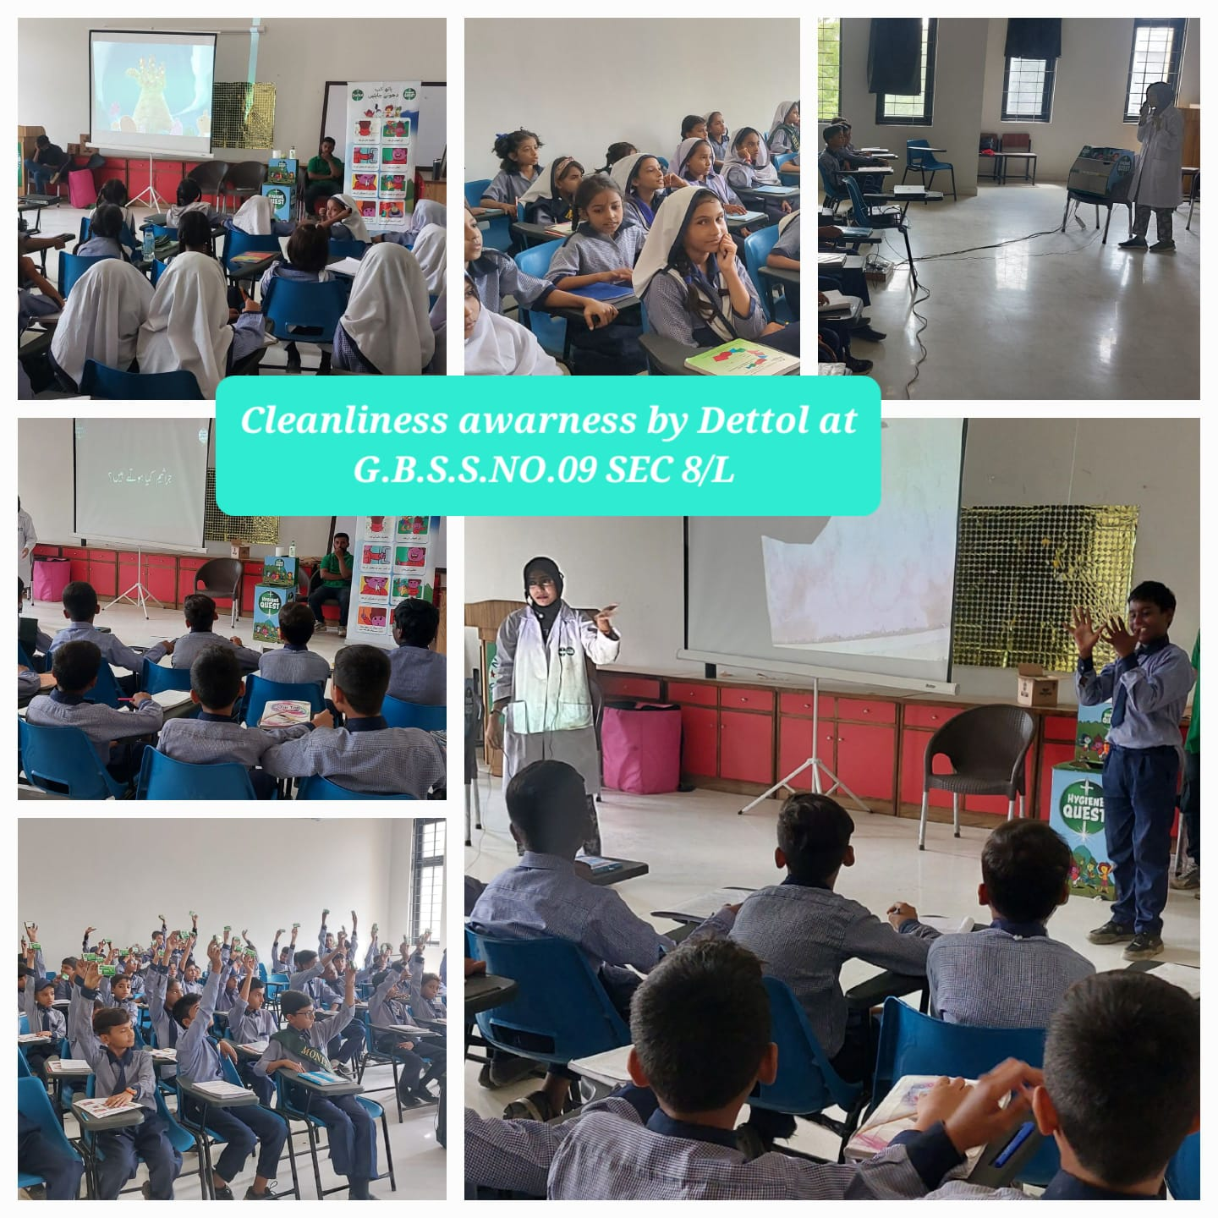
DETTOL HEALTH AND HYGIENE SESSION Parent Teacher Meeting

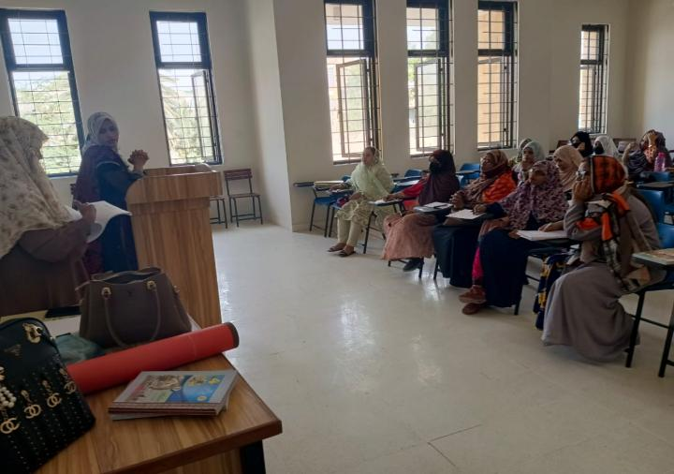
Refresher training regarding Lesson planning & Coverage of syllabus

